# Output files

The following shows the possible output files of programs:

A_rgb_destiny_cluster.py:

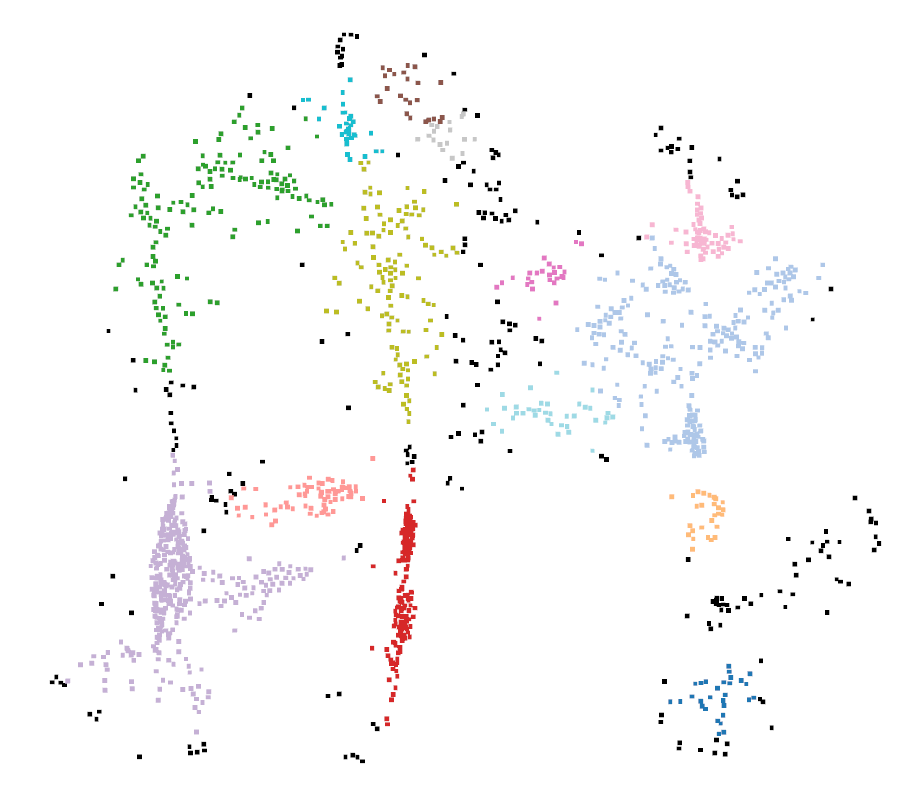

B_mainwaypoint.py:

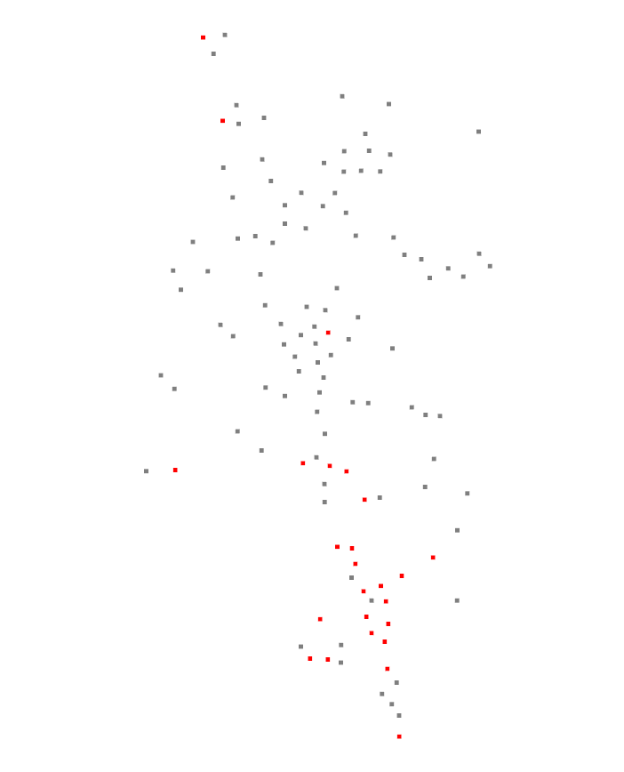

D_route_plan_cluster.py:

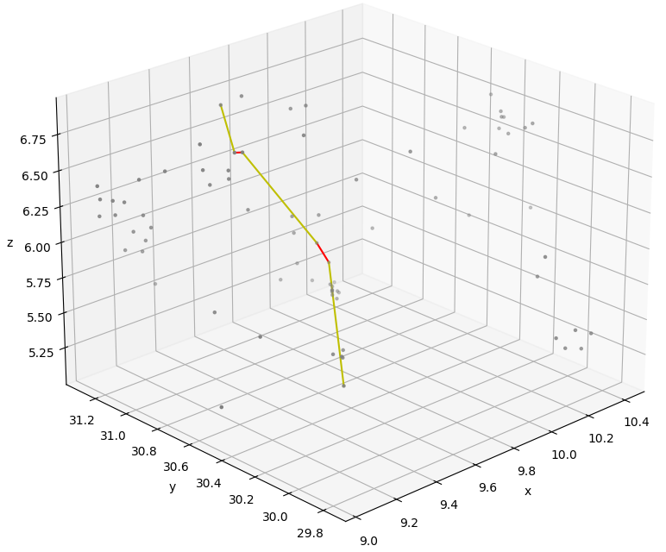

E_route_plan_all.py:

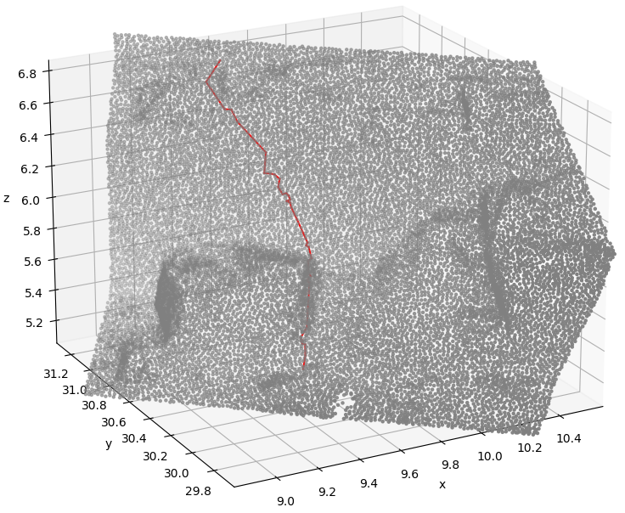

F_globall_view.py:

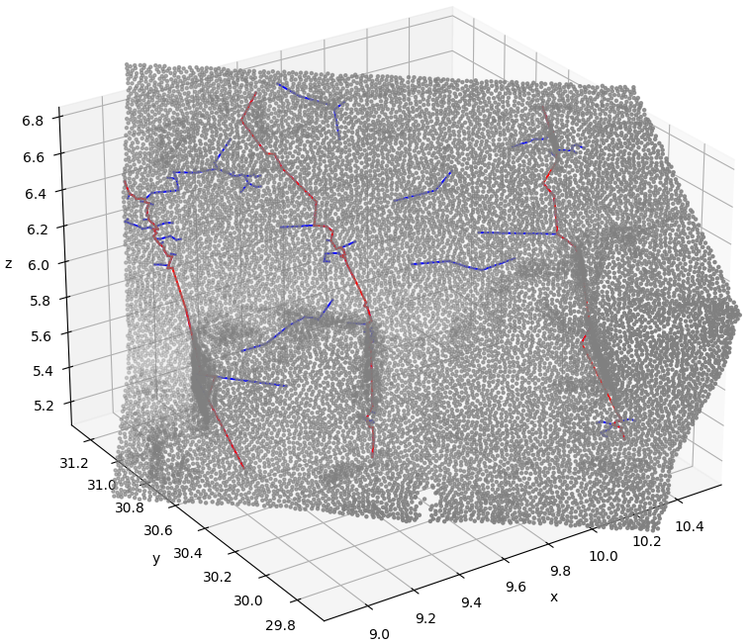

G_rough_plan_all.py:

